AWS Web Application Firewall (WAF)

TASK: Block my laptop ip using WAF.

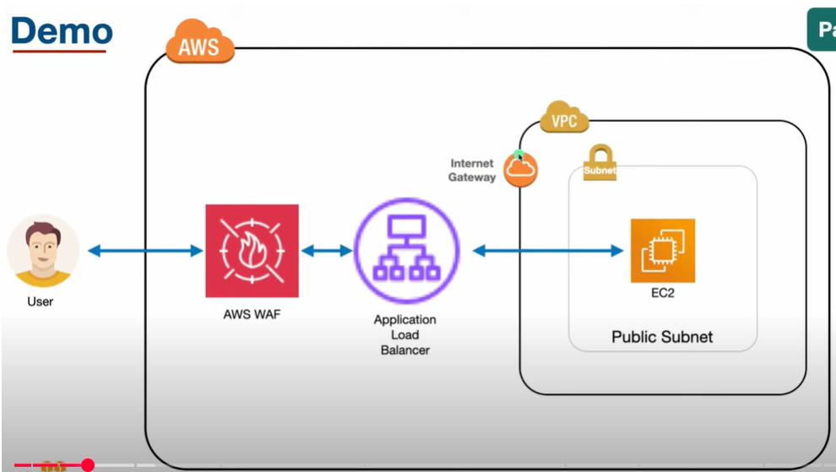

1. Create a VPC , two different subnets in different zone and create a route table and connect igw, and create a EC2 and install apache, make sure security group inbound rule allows traffic for port 80.
2. 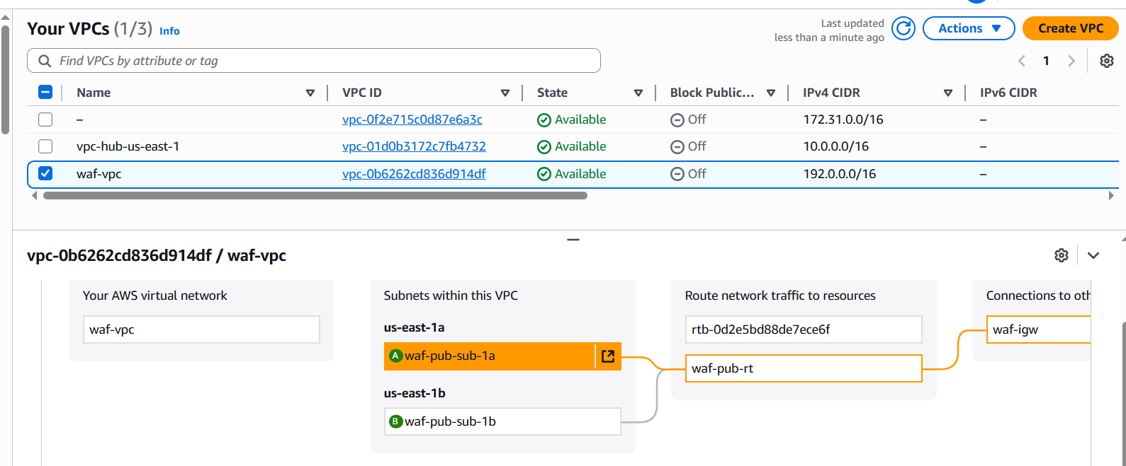
3. 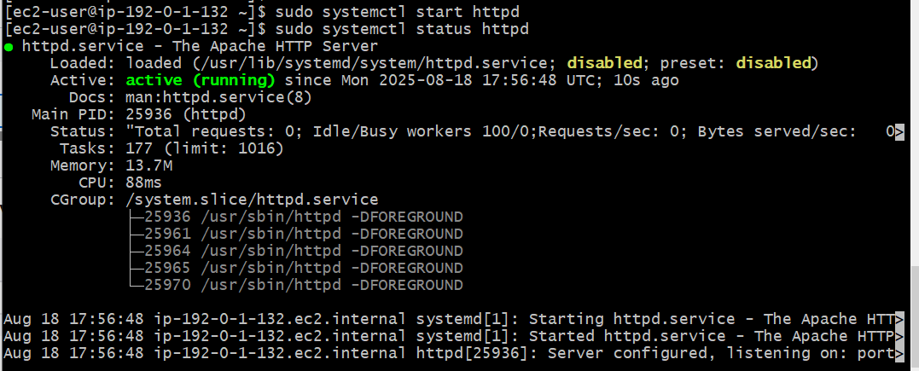
4. Created a target group by adding instance and create a application load balancer with listener http port and attached the group.
5. 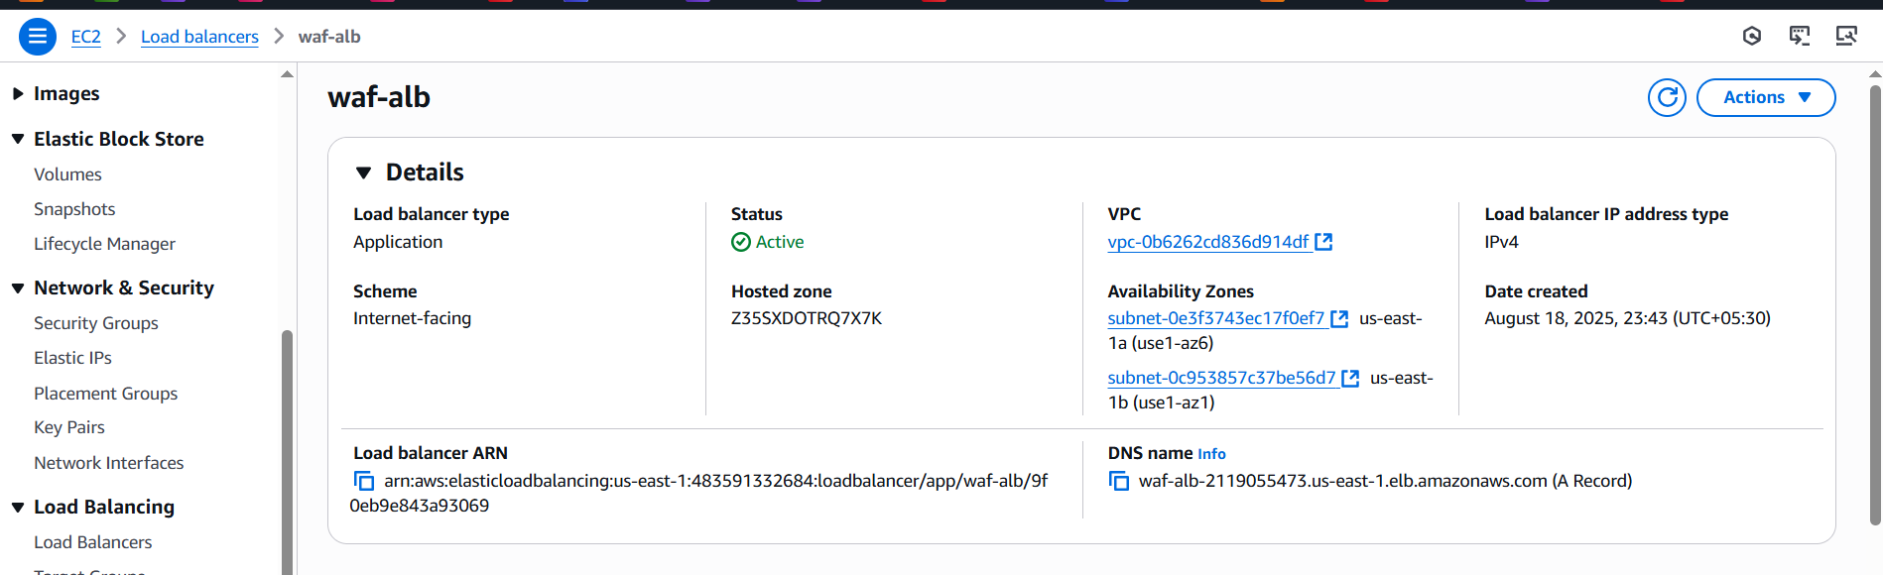
6. 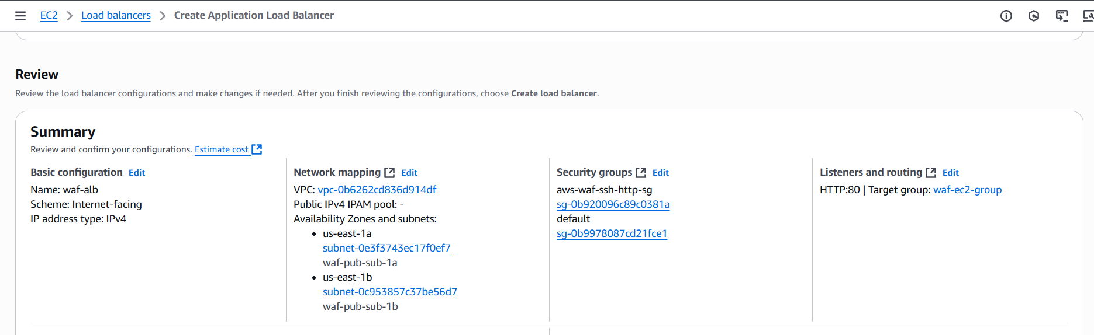
7. Go to AWS WAF → IP SETS added my laptop for block.
8. 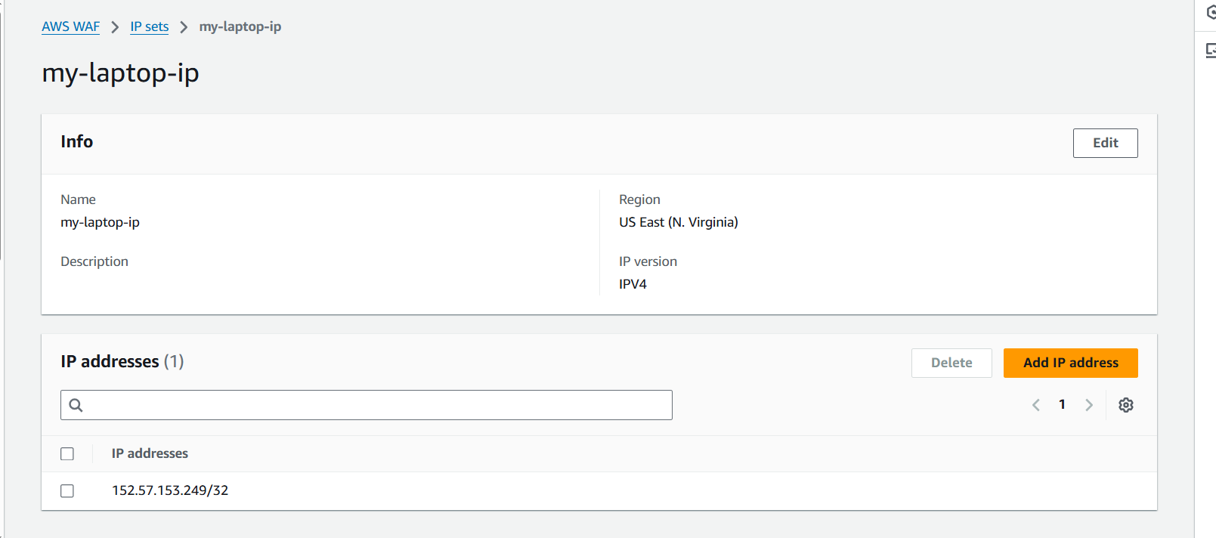
9. Now created web application firewall and add the rule with above ip set.
10. 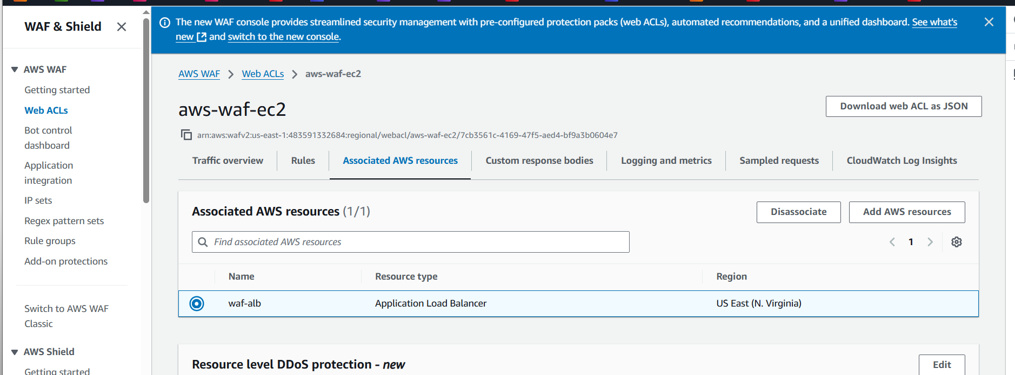
11. 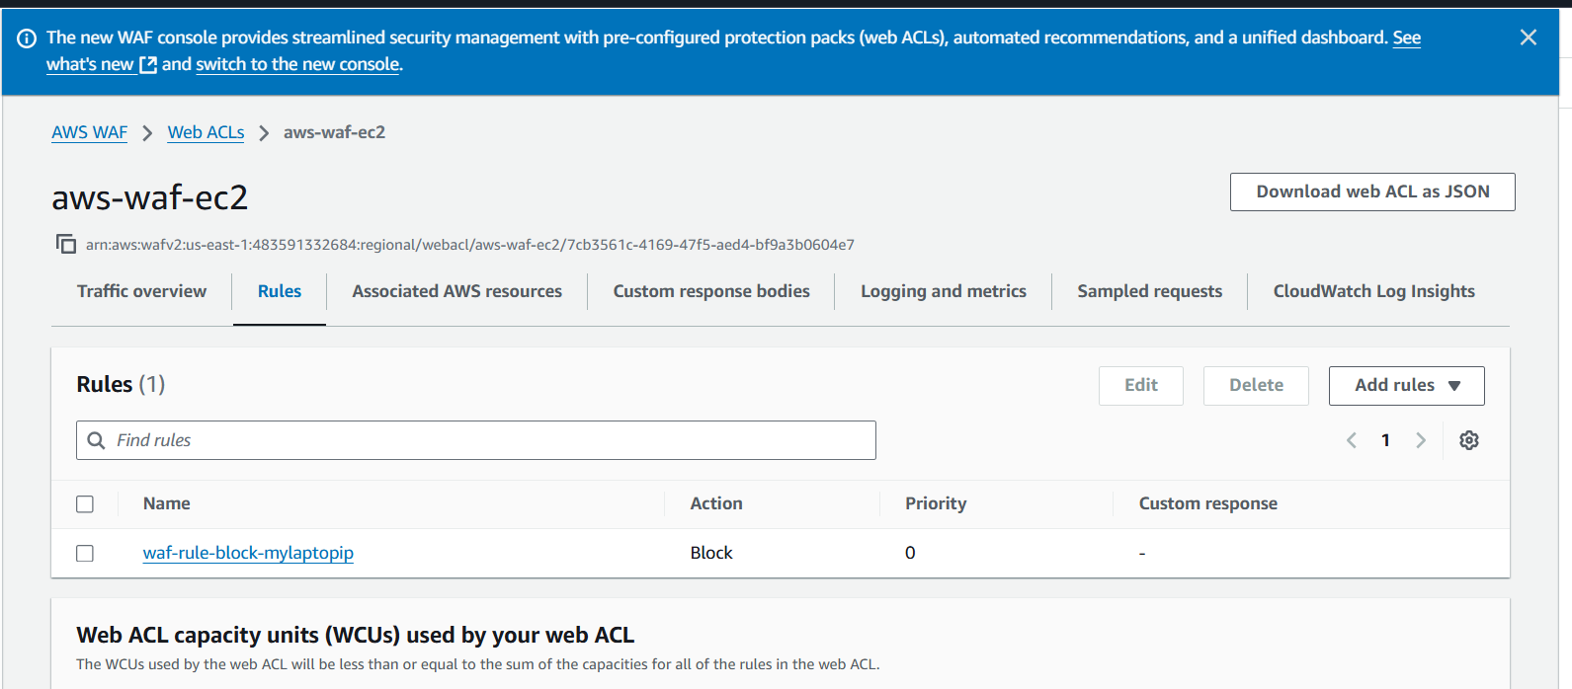
12. Now copy the dns name and check in url
13. [waf-alb-2119055473.us-east-1.elb.amazonaws.com](http://waf-alb-2119055473.us-east-1.elb.amazonaws.com)
14. You will blocked.
15. 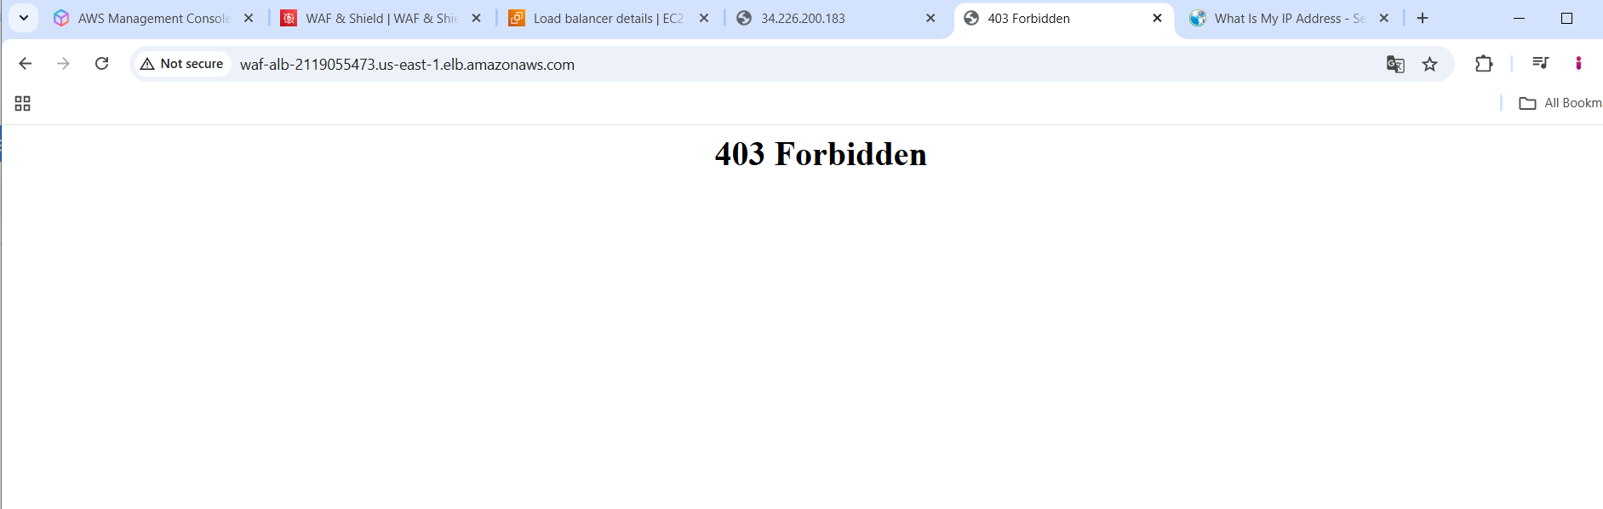
16. Now in web acl edit the rule as captcha you will get this.
17. 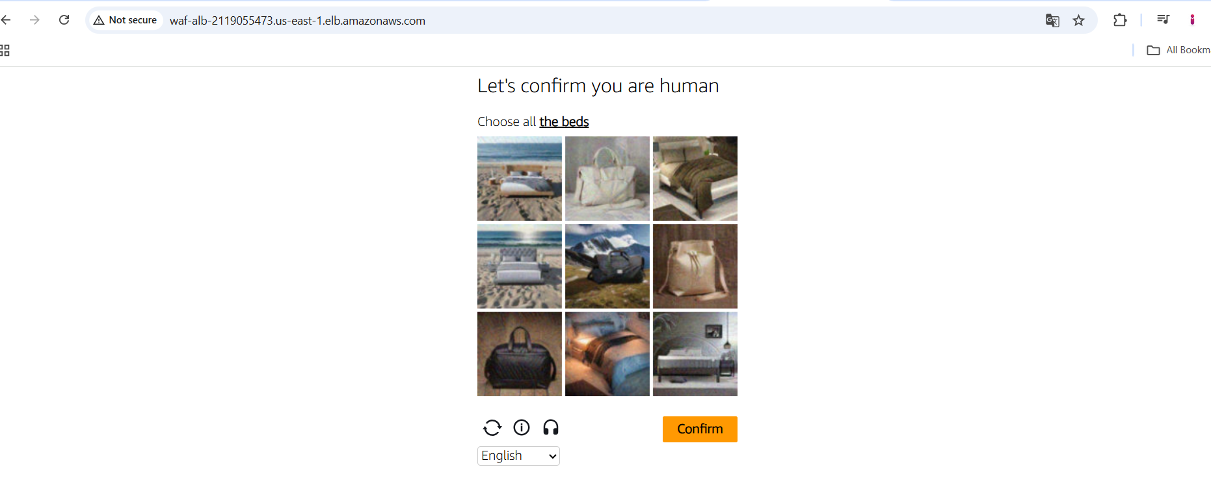
18. Then its redirected to apache page
19. 